5-2 Milestone Four: Enhancement Three: Databases

Marie Igoe

Southern New Hampshire University

January 31st, 2021

# Narrative

The artifact that was used for the third category in regards to databases is from course CS340 (Advanced Programming Concepts). This project was about implementing the CRUD operations in MongoDB. This artifact was included to demonstrate the ability to manipulate a NoSQL database. For the enhancement, I installed mongodb onto my computer and preformed tasks including: finding and replacing a document, adding a user, updating user permissions, revoking permissions, and more. As shown in the screenshots, there were commands utilized after preforming tasks such as the “db” command. This was used before inserting documents to ensure they would be inserted into the correct db or collection. I was able to meet the planned enhancements for this artifact.

As I was working on this enhancement, I had a hard time getting access to the virtual environment in which I used for CS 340. I ended up installing it on my computer through the terminal. I did learn that I should have installed it on my computer to begin with and to avoid the delay. Regarding working with mongodb, I did not run into many issues. I did have to use online resources such as Stack Overflow as I had issues installing it on my Mac. Overall, this artifact was a great refresher to working with and manipulating a NoSQL database.

# Enhanced Artifact: Databases

Start mongodb:

**mongod**

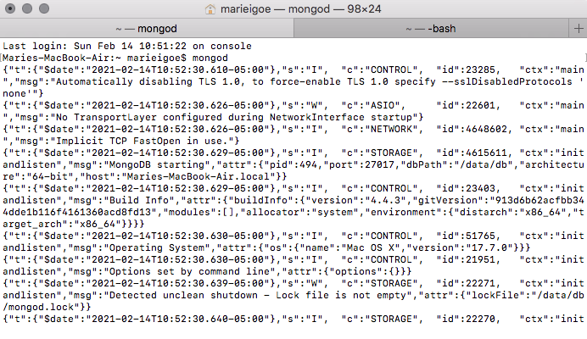

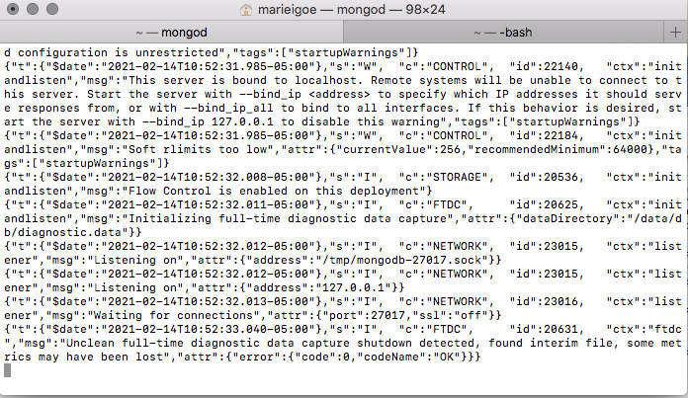

Open new tab in terminal to interact with mongodb:

**mongo**

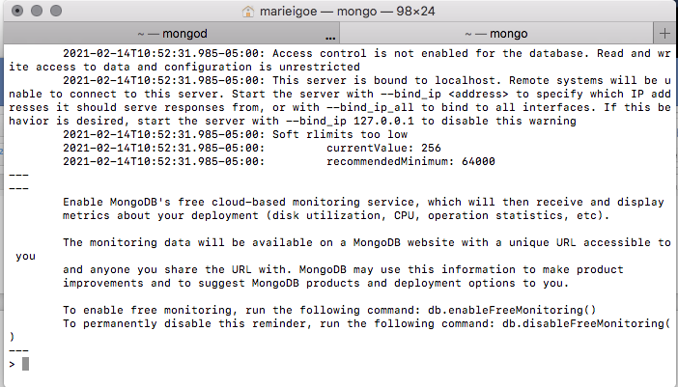

Show available databases

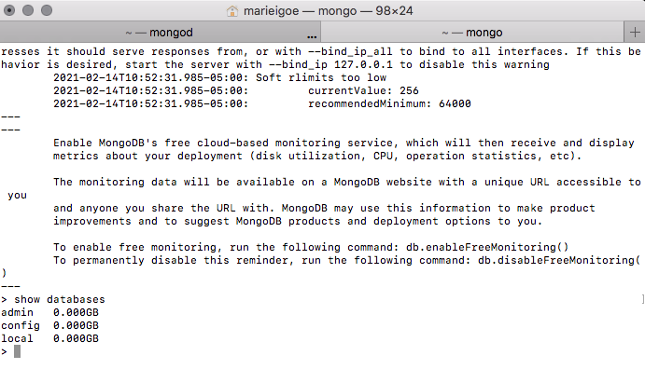

Show current db:

**db**

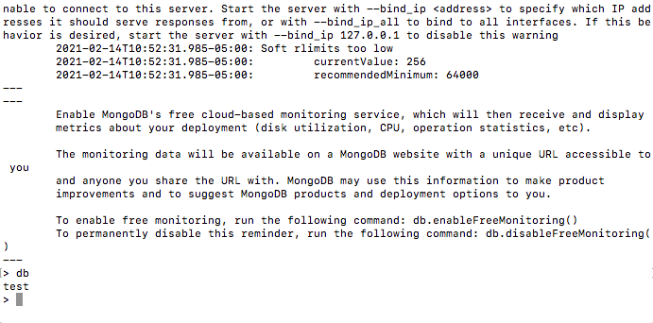

Switch to local database

**use local**

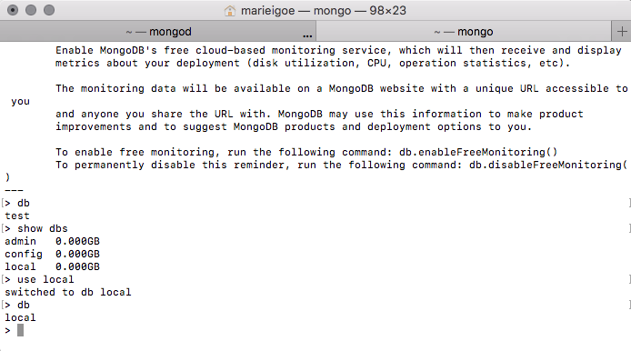

Create a database named artifact:

**use artifact**

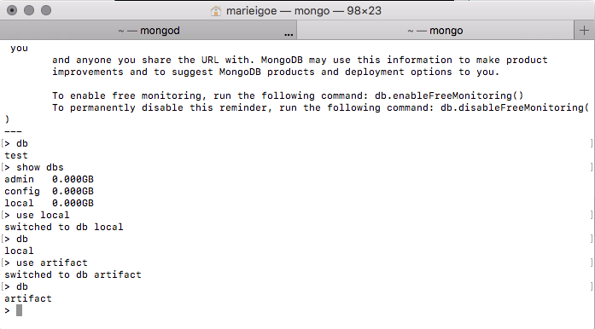

*Note: New db will not show on the list because it will not be created until a document is saved in it:

**Show dbs**

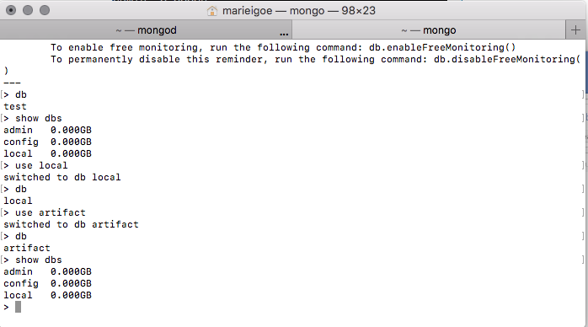

Create collection user and insert a document in it

**db.user.insert(**

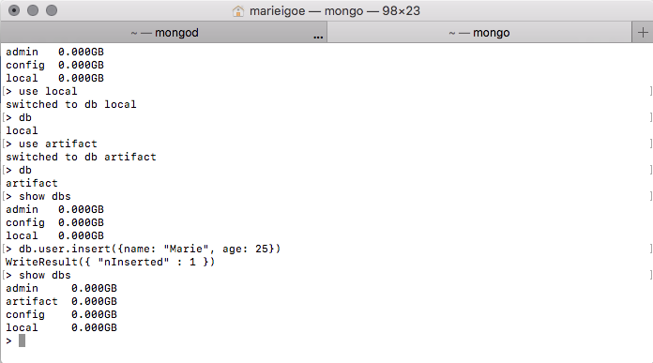

Next, added a database named Test and added a user to it for the next commands.

Dropping the test database:

**show dbs**

**use test**

**db.dropDatabase()**

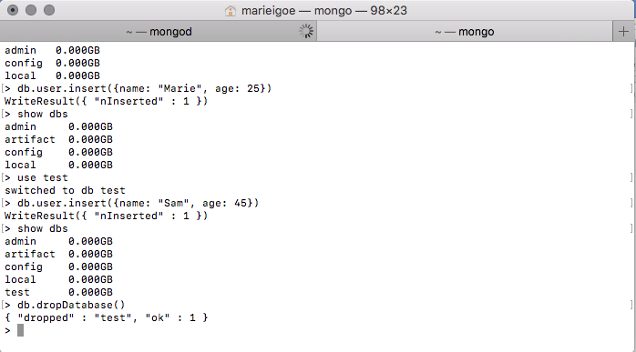

Create a collection in a database:

**db.createCollection(**

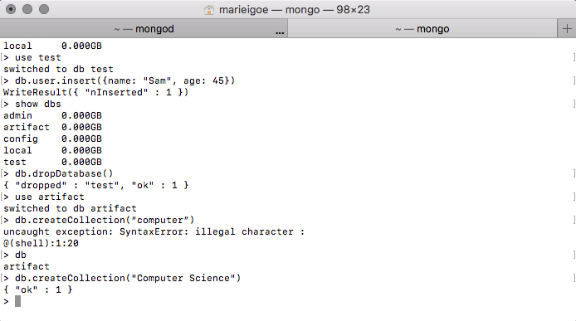

Show collections in a database

**show collections**

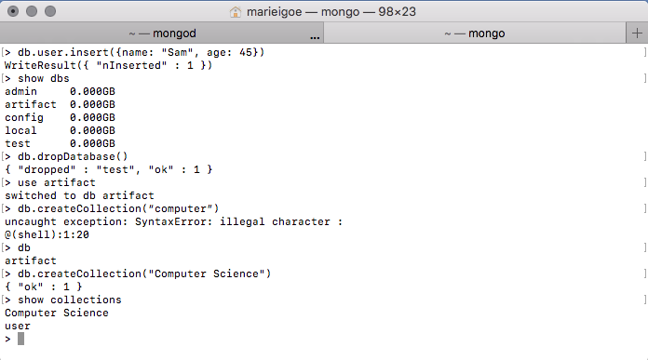

Drop a collection in a database

**db.Software.drop()**

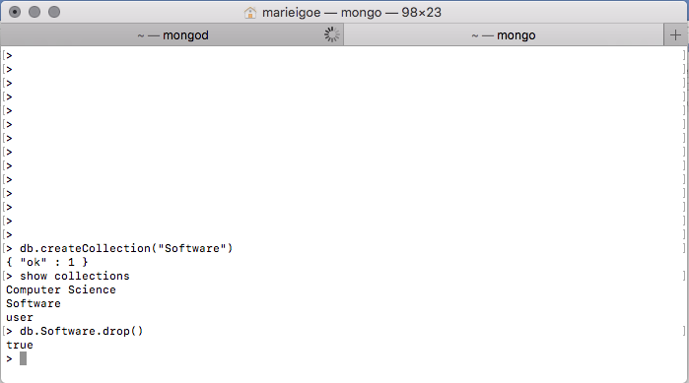

Insert documents into a collection:

**show collections**

**db.Documents.insert(**

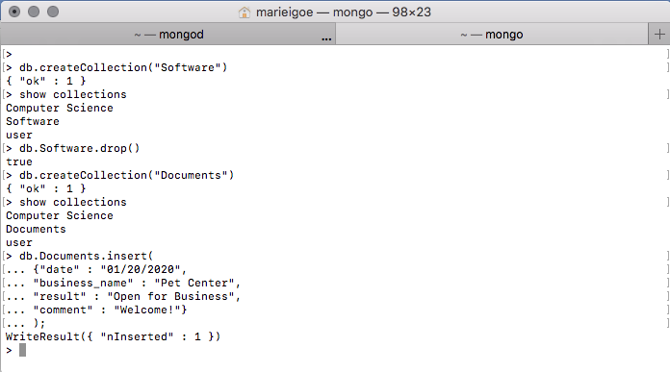

Update a document in a collection:

**db.Documents.update**

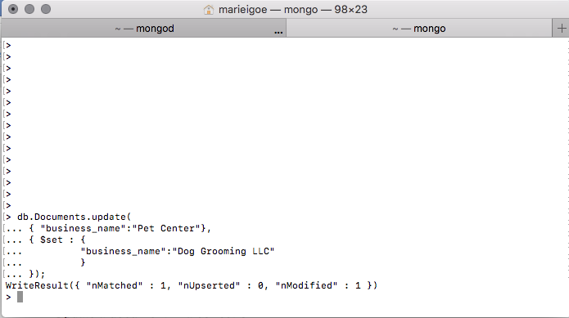

Get all documents in a collection:

**db.Documents.find()**

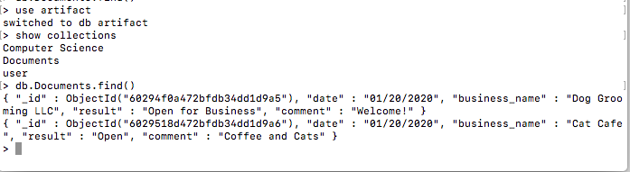

Get first document in a collection:

**db.Documents.findOne()**

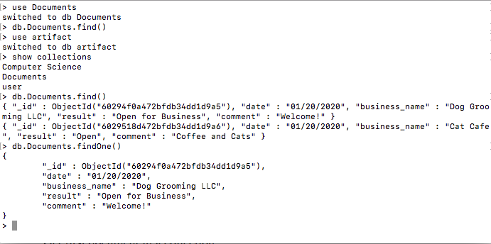

Find and replace a document:

**db.Documents.findOneAndReplace(**

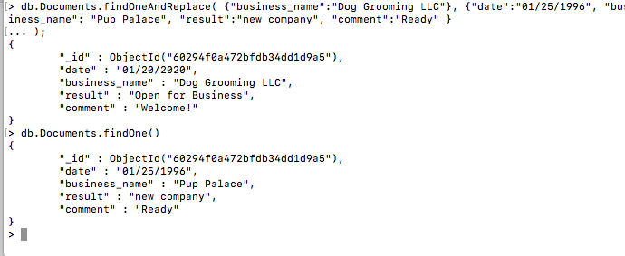

Find and delete a document:

**db.Documents.findOneAndDelete(**

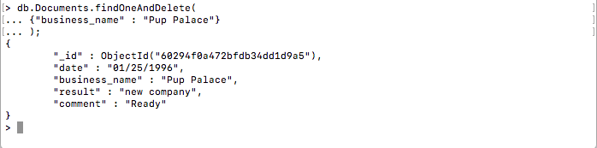

Get all matching documents in a collection:

**db.Documents.find(**

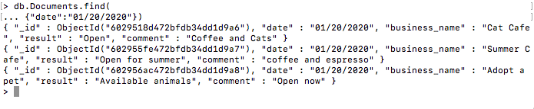

Add database user with specified roles:

**db.createUser(**

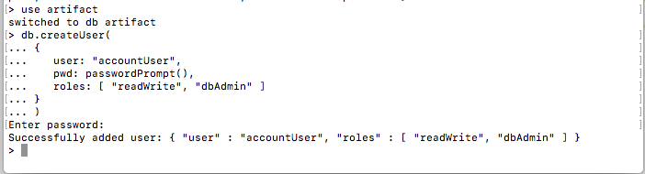

Get details of all database users:

**db.getUsers()**

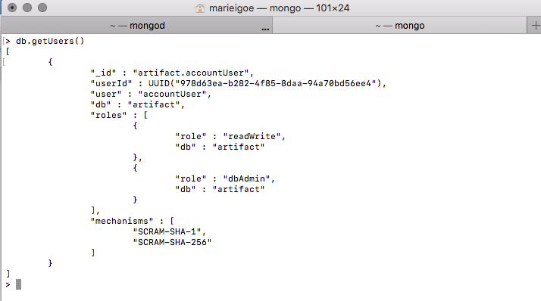

Revoke roles from a user:

**db.revokeRolesFromUser(**

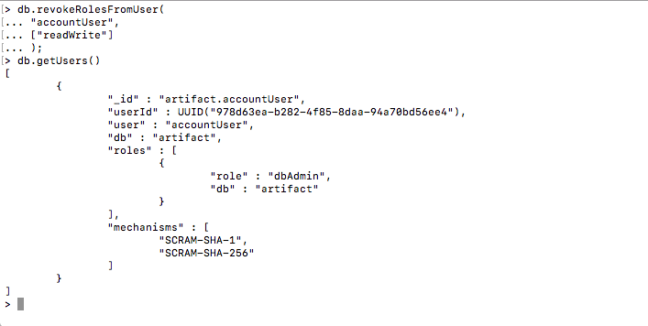

Authenticate to the database from shell

**db.auth(“accountUser” , passwordPrompt())**

